**Hello World Tutorial**

# Tutorial Creating a script

in this tutorial we're going to write our very own hello world program using the unity game engine.

Let's start off by creating a new unity project titled “Learn C Sharp”.

Notice I'm spelling out sharp rather than using that sharp symbol that we're used to seeing these symbols are a little bit problematic whenever it comes to file folder project name, so I'm just going to leave it out.

Set your desired file location, create project. Unity is going to relaunch into the unity editor which looks like this:

We're going to start off in the assets pane. I’m going to right click in assets “create c-sharp script” and give my c-sharp script a name.

I’m going to call it “ExampleClass”. Notice the capital e capital c no space in between example class.

Now I can open these one of two ways; I can right click and say open or I can just double click and it's going to open it up in visual studio code.

All right the simplest way to see if we're actually running a script successfully is to output to the console in unity. We can easily do this by using a command called “debug log”. Open a parenthesis you'll notice Visual studio code automatically closes the parentheses when I open it.

In those parentheses I'm going to put a quote, again automatically closes the quote for me, type in “hello world”.

Every C# script we write we need to make sure we finish with a semicolon so again at the end of the line write a semicolon.

It doesn't do us any good if we don't save at this point, so ctrl s on a pc command or of course go up to “File” and click “Save as”.

So, I've saved it you can minimize, or you can close.

If we look now with our script selected in the inspector you can see the script has actually updated it says debug log “hello world”.

Alright, so we're going to go up to the very top to the run play button I'm going to click on the run play button, and nothing really happened except the preview window changed from scene the game and the colour of the editor changed got a little bit darker. The “hello world” message that I expect to see when first trying a program, so what did we do wrong?

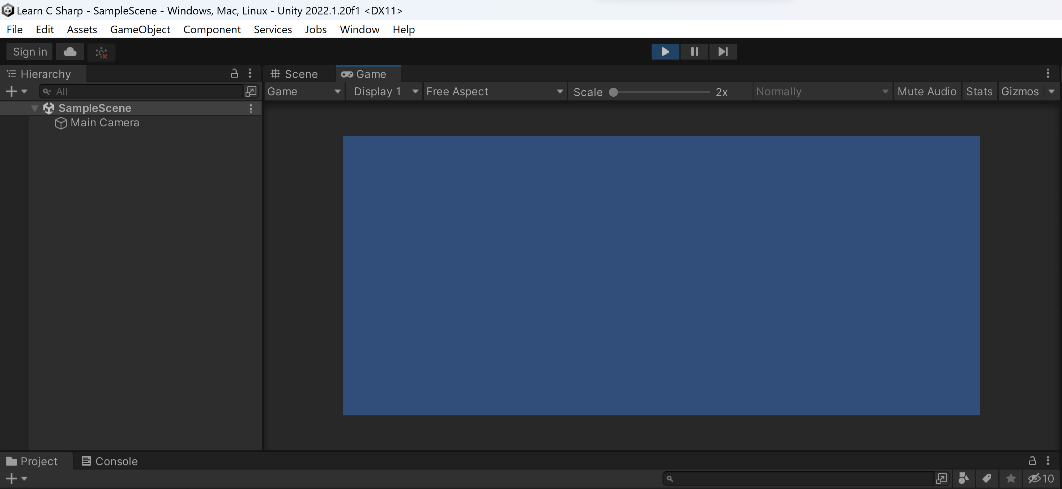

Well let's start off by clicking that run play button again to stop running the scene, try to think of this as a toggle switch or running/not running and not simply a just a start button.

To execute a script, it must be attached to an object. We could attach this script to any object including main camera and directional light, either one.

However, this is not a best practice and we don't want to build bad habits so let's create an object to attach the script to in the hierarchy on the left, I'm going to hit create and then select “create empty” it just creates an empty placeholder object that I can put my script on.

Now we have a game object called “game object” in the hierarchy, it's kind of a messy name let's give it a more meaningful name. In the inspector, over here on the right, I'm going to change game object to debug it's the object that's going to allow me to run my debug.

All right I have a couple of ways that I can attach this script I could click it and I could drag it on and I'll add it that way, or I could hit add component go down to scripts and then select “example class”.

All right so I have my debug object, just a placeholder object with my script attached so let's try running.

I'm going to hit the run play button again up at the top and look down here bottom left hand corner “hello world” we’ve done It. To get a better view, right up here there's a console tab right next to the project tab click on console and it's going to show me the complete Read out hello world unity engine debug log object.

